Master’s and Doctoral Thesis Evaluation Procedure and Schedule
- First Semester 2024

<Key Dates>
Process | Schedule | Notes
Thesis evaluation | March 2024  to June 2024 | Detailed evaluation schedule to be determined autonomously by each department
Payment of thesis screening fee | By June 21, 2024 (Fri) | Payment should be made to a virtual account at Shinhan Bank before the thesis evaluation date
Submission of printed thesis and related documents | By June 27, 2024 (Thu) | Student → Department
Online Submission of the Digital Copy of the Thesis | June 21, 2024(Fri)  - June 28, 2024(Fri) | Student  → University Library

<Key Requirements>
Requirement | Details
Size of external Thesis Committee | Master's degree: One (1) person or none  Doctoral degree: Minimum one (1) person, up to three (3) persons
Thesis evaluation procedure | Thesis evaluation including oral defense  Master's degree: One (1) or more times  Doctoral degree: Two (2) or more times
Number of hardbound copies of thesis to be submitted | Three (3) copies for both master's and doctoral degrees
Academic Journal Publication Record | Candidates for doctoral and combined master’s and doctoral degrees, who entered the program in the 2014 academic year or later, must publish one (1) or more papers in any journal recognized by their department while enrolled as a student.  ※Candidate must be the lead author (first author or corresponding author) of one (1) or more papers.

I. Composition of Thesis Committee

1. Qualifications of Thesis Committee members: Internal or external full-time faculty members with a Ph.D. degree, or those recognized by the dean of each graduate school or college concerned.

2. Composition of Thesis Committee: Three (3) or more persons for the master's degree, five (5) or more persons for the doctoral degree.

(1) One (1) of the Thesis Committee members for the master's degree and three (3) of the Thesis Committee members for the doctoral degree may be appointed from among external personnel; for the doctoral degree, at least one (1) of the Thesis Committee members must be appointed from among external personnel.
(2) Definition of external personnel: “external personnel with expertise in the field that is being examined” recognized by the dean of each graduate school or college concerned.
However, internal full-time faculty members and faculty members on a special contract (visiting professor, guest professor, adjunct professor, research professor, honorary professor or professor for university-industry cooperation), instructor, professor emeriti, chair professors, and the external thesis advisor of the candidate being examined are excluded.

3. Appointment of Thesis Committee: Thesis Committee members are appointed by the dean of each graduate school or college concerned upon recommendation of the thesis advisor after deliberation by the Graduate School Academic Steering Committee.

II. Thesis Evaluation Procedure

1. Confirmation of candidates for thesis evaluation: Students who have passed the comprehensive examination and registered for the required Thesis Seminar Course (Master’s: Z0001, Ph.D. / Combined Master’s and Ph.D.: Z0002)

(1) Go to [Eureka Login (유레카통합행정(마이유레카)) → Academic Affairs (학사) → Course (수강) → View Course Registration (수강신청내역조회)] to check: Candidates for thesis evaluation for the current semester are those students registered for the Thesis Seminar Course (Master’s: Z0001, Ph.D./Combined Master’s and Ph.D.: Z0002).

2. Evaluation period: March 2024 – June 2024

(1) Candidates should fill in the attached Candidate Confirmation Form (Master’s / Doctoral / Combined) (Attached Document 1) and submit it to their department before beginning the evaluation, and please confirm the following items.
(a) Payment of thesis screening fee
(b) Fulfillment of English test requirement (※Foreign students may submit results of the English or Korean test beginning from the first semester of 2018) and the results of a second foreign language test (as specified by the department).
※ For students who have checked “Submission expected during the first semester of 2024” on their Candidate Confirmation Form, please make sure that the submission is made within the submission period. (Submission period for English test requirement and deadline for second foreign language test requirement: May 20 – May 24, 2024).
(c) Completion of Research Ethics Course (Mandatory for candidates who entered the program in the 2014 academic year or later): As one of the qualifications for thesis evaluation, this course should be completed by the end of the semester preceding the general evaluation. However, candidates unable to complete this course before taking the thesis seminar may submit their Research Ethics Course Certificate together with the thesis prior to their thesis evaluation date.
(d) Submission of Pledge of Compliance with Research Ethics: As part of university efforts to reinforce research ethics, all students taking the thesis seminar should submit a Pledge of Compliance with Research Ethics (Attached Document 2).
(e) Submission of Thesis Originality Check Report: Candidates must conduct a similarity test through Turnitin, a plagiarism prevention system provided by the University Library, and submit a Thesis Originality Check Report (Attached Document 3) with confirmation of the test results by a thesis advisor.
※ For more information, please refer to the “Thesis Originality Check Guidelines” on the last page of this packet.
(f) Academic Journal Publication Record (applies to candidates for doctoral and combined degrees who entered the program in the 2014 academic year or later): In order to graduate, degree candidates must publish one (1) or more papers as the lead author (first author or corresponding author) in any department-recognized journal while enrolled as a student.

[Detailed Regulations for the Application of Graduate School Laws] Article 52-2 (Publication of papers while in school) (1) A Ph.D. candidate shall publish one (1) or more papers as the main author (first author or corresponding author) in any journal recognized by his/her department while enrolled in school.
(2) A Ph.D. candidate for practical training may submit research results as specified by his/her department while enrolled in school, thereby substituting for the publication of papers pursuant to Article 52-2(1).
(3) Research results pursuant to Article 52-2(1) and Article 52-2(2), or documents certifying the same shall be submitted together when the thesis is submitted for acceptance under Article 52.

(2) The department shall determine and execute the evaluation schedule autonomously insofar as it can meet the deadline for submission of the final results of the thesis evaluation to the administrative offices concerned ((June 27, 2024(Thu)).

3. Payment of thesis screening fee

(1) Thesis screening fee: 168,000 won for master’s degrees; and 795,000 won for doctoral degrees

(2) Payment period: March 18, 2024 (Mon) to June 21, 2024 (Fri)

Payment must be made before the thesis evaluation date.

(3) Payment method:

(a) Print thesis screening fee bill: Go to [Eureka Login (유레카통합행정(마이유레카)) → Academic Affairs (학사) → Graduation (졸업) → Thesis Screening Fee Application (논문심사비납부신청)], click Request (신청) (A virtual account number will be generated), and then click Print the Bill (고지서출력).
(b) Transfer funds to the virtual account: Wire the thesis fee to the payment account number on the bill, which is a dedicated virtual account in your name as the applicant, at any financial institution (through a bank teller, Internet banking, telephone banking, or ATM transfer).

4. Evaluation and decision

(1) Master’s degree: Thesis evaluation including oral defense shall be conducted one (1) or more times. The thesis may be accepted with the approval of two-thirds (2/3) or more Thesis Committee members.

(2) Doctoral degree: Thesis evaluation including oral defense shall be conducted two (2) or more times. The thesis may be accepted with the approval of four-fifths (4/5) or more of the Thesis Committee members.

5. Submission of printed thesis and related documents (Student → Department)

: By June 27, 2024 (Thu)

(1) Three hardbound copies of the final version of the Master’s or Ph.D. thesis (including the Thesis Approval Form bearing the signatures of the thesis advisor and examiners)

※ Spelling, spacing, and punctuation including any hyphens in the foreign student’s name should be identical to the information in the School files.

※ The submitted thesis should be signed by all Thesis Committee members (Article 52-2 (2) of the Detailed Regulations for the Application of Graduate School Laws).

(2) Pledge of Compliance with Research Ethics

(3) Thesis Originality Check Report(with Digital Receipt)

(4) Academic Journal Publication Record for the Doctoral Thesis (applies to students for doctoral and combined degrees who entered the program in the 2014 academic year or later)

※ Candidate must be the lead author (first author or corresponding author) of one (1) or more papers.

(5) Questionnaire for Ph.D. Graduates (Form to be provided later): Survey conducted by the Ministry of Education on candidates for doctoral degrees.

(6) Photocopy of the cover page of the hardbound copy of the thesis (NOT the electronic copy)

III. Online Submission of the Digital Copy of the Thesis
(Contact the University Library at 02)3277-4614 for further information)

1. Student → University Library: June 21(Fri) – June 28(Fri), 2024

2. Submission Process

(1) Print your final hardbound version of the thesis using a printing service of your choice, and visit the University Library homepage to submit the digital file used for printing via the online thesis submission webpage.

(2) Submit here: University Library homepage (도서관 홈페이지) → Collections (컬렉션) → Digital Ewha (디지털 이화) → dCollection EWHA → Submit(자료제출)

(3) File format: Choose one among Hangeul / MS Word / PDF. (File name is at your discretion, but do not use periods.)

(4) After online submission, wait for a submission confirmation text message to be sent by the University Library. Once the message is delivered, print out the Permission to Exercise Author’s Rights and the Online Submission Confirmation via [dCollection EWHA → Submission list (제출내역)]. Submit these two documents along with the hardbound copies of the final thesis to your School. (Do not submit to the University Library.)

3. Helpful Tips

(1) The digital file submitted online must be identical to the file used to print the final hardbound version of the thesis submitted to your School. It is advised not to submit online before the completion of printing and hardcover binding by your printing service.

(2) The University Library cannot verify whether the thesis submitted online meets the thesis formatting requirements of your School. Please verify the thesis formatting requirements and related guidelines thoroughly before printing your final thesis.

(3) Please check once more page numbering with the guidelines in thesis format. Also please note that all the names of thesis committee members should be on the confirmation statement page.

IV. Thesis Formatting Requirements

1. Refer to the following webpage: Graduate School homepage (http://graduate.ewha.ac.kr) (일반대학원 홈페이지) → Academic Affairs (학사안내) → Degrees / Thesis Evaluation and Formatting Requirements (학위수여/논문심사및제출서식) → “Thesis Formatting Requirements” and “Thesis Formatting Templates” (“학위청구논문체제” 및 “학위청구논문 템플릿”)

2. Academic Year, Graduation Year, Date of Submission on the Cover and on the Title Page

<Form 1> Cover
The academic year on the top left must be written as “2023학년도” (Academic Year 2023), and the year on the bottom as “2024”.
<Form 3> Title Page
The date of submission in the middle indicates the month of submission of the final thesis, between “2024년3월” (March 2024) and “2024년 7월” (July 2024).

V. Public Announcement of Dissertations for Doctoral Degrees

Any person that has obtained a doctoral degree shall publicly announce her doctoral degree dissertation within one year from the date on which she received the said degree, as prescribed by the Minister of Education. However, this shall not apply to a case where the Minister of Education deems it inappropriate to publicly announce such a dissertation.

※ Form of Public Announcement
Publication in book form, publication in a related academic journal (Volume O, Issue O), publication in a foreign international academic journal, presentation in an academic seminar, or other (“Other” refers to submission to the University Library Homepage.)
※ Please visit the Graduate School homepage for further dissertation-related information.

Thesis Originality Check Guidelines

1. Definition of “Plagiarism”

“Plagiarism” is the act of using the ideas, research results, or other creations of other people without adequate citation or permission. (Rules of the Research Ethics Committee of Ewha Womans University)

2. Objective of Plagiarism (Similarity) Test

(1) To prevent plagiarism by giving researchers an opportunity to verify sources and data related to sections that are detected to be similar to existing material from webpages, major newspapers, magazines, journals, theses and project materials, books, and other academic publishers.
(2) To prevent researchers from making the honest mistake of omitting citations or references, thus avoiding suspicion of plagiarism.

3. How to Conduct Plagiarism (Similarity) Test

(1) Plagiarism (Similarity) Test Tool : Turnitin
(2) Manual : Library homepage(도서관홈페이지) → Research(연구·수업지원) → Research Tools(논문작성가이드) → Plagiarism Prevention (표절예방 및 연구윤리)
(Contact the University Library at 02)3277-3396 for further information.)

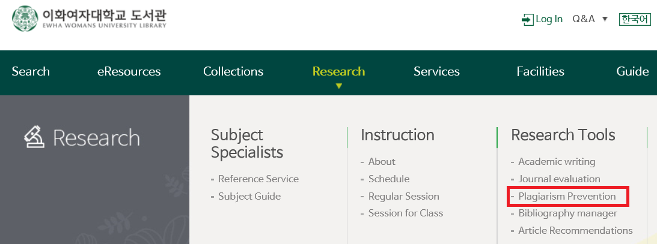

(3) How to Use : Create ID/PW at Turnitin homepage.(https://www.turnitin.com/) → Log in with ID/PW and Check Similarity Test. → Click the Similarity % to check the Turnitin Similarity Test Result and Download the Digital Receipt from the result view screen.

1) How to Create Account and Enroll in a Class
- Click 'Create Account' at Turnitin homepage.
At Create a User Profile Homepage, Click “Student” link to Make Your ID/PW.
Use school e-mail(@ewha.ac.kr, or @ewhain.net) as e-mail address.
If you don’t have email, make one at Ewha Portal.

※ If you have never created an account on the Turnitin homepage, but it is an account that already exists, you need to find the password on the Turnitin homepage.
- Check your Turnitin Class ID/PW after logging in the Library homepage. Click [Ewha's class ID/class password(login needed)] on [Library Homepage > Research > Research Tools > Plagiarism Prevention].

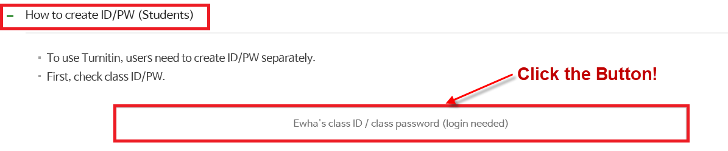

※ How to Register for a New Class
① Log in the Library homepage. (https://lib.ewha.ac.kr) → Select ‘ENG’ in Library homepage.
② Check your Turnitin Class ID/PW on [Library Homepage > Research > Research Tools > Plagiarism Prevention].
③ After logging in to the Turnitin homepage(https://www.turnitin.com/), Click the [Enroll in a Class] tab at the top left.
④ Enter the ‘Class/section ID’ and ‘Enrollment key’ found on the Library homepage and Click “Submit”.

2) Submit the file to Assignments
Log in at Turnitin homepage and Click "Ewha Womans University" Class.
Select one of 15 assignments and Click "Submit".
After checking your paper 4 times with the same button, more than 5th Re-uploaded file will require an additional 24 hour delay to generate.
For immediate results after 5 submissions, please submit to the next assignment box.

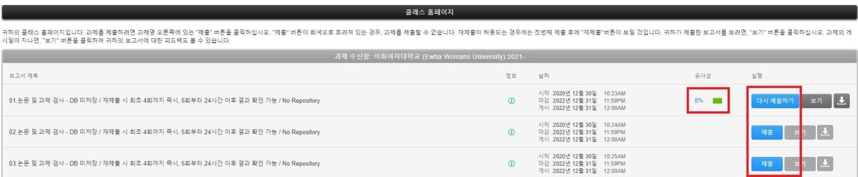

3) Check Thesis Similarity Result and Download Digital Receipt
Click the Similarity % on Turnitin to Check the Similarity Result.
After checking similarity at Turnitin and discuss the result with advisor. To discuss with advisor, ① Download the pdf of the Results "Current View".
To Submit to the Department, ② Download pdf file of “Digital Receipt”.

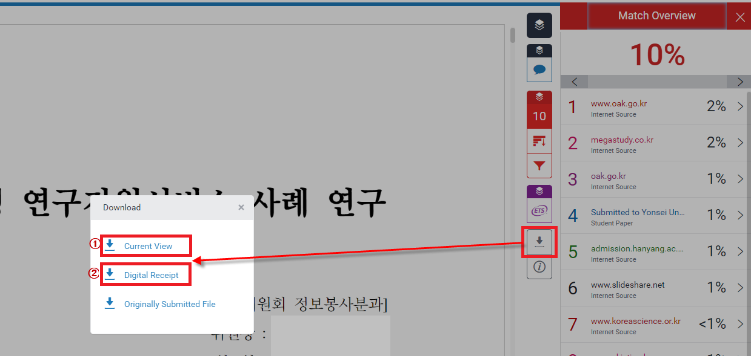

(4) Notice

1) File with PDF type is recommended. Hangul or word is possible.
If there is an error when uploading the file, convert the original file to PDF file and upload again. Select "Adobe PDF" from the printer settings after "Printing" in the Hangul or Open the file in Adobe Reader, Click "Enable Editing" at the top right and save it as PDF.

2) There may be errors in Internet Explorer, so Chrome, Safari, Firefox, and Edge browsers are recommended.

4. Use of the Test Results and Submission of the <Thesis Originality Check Report>

(1) The result of the Turnitin similarity test alone cannot confirm or eliminate the possibility of plagiarism. The object of the test lies less in determining plagiarism than in giving researchers an opportunity to make appropriate modifications and remedies, such as adding citations and references.
(2) Researchers must print out the Similarity Test Result Report (Similarity Report) and, if necessary, make appropriate remedies to sections (marked with numbers and highlights) where similarities are detected, after consulting with their thesis advisor. Thesis advisors should fill out the <Thesis Originality Check Report> based upon the modifications and remedies made after reviewing the similarity test result.
(3) Researchers are advised to conduct similarity tests before thesis evaluation, so that the thesis can be evaluated in its most complete form. Since the program allows multiple tests on one thesis, remember to retest after any modification of the thesis. At the time of thesis evaluation, submit the <Thesis Originality Check Report> along with the digital receipt to your department.

